National University of Lesotho
Department of Mathematics and Computer Science
CS4433 Software Engineering
Learning Management System (LMS)

Software Design Document

Deliverable for Week 3 (5-9 Oct 2026)
Phase 3: System design (24 marks); Phase 5 test plan
Milestone: G2 Gate 2 - design review (7 Oct)
Student: [Full name]
Student number: [Student number]
Supervisor: [Supervisor name]
Date: 7 October 2026

Table of Contents
Table of Contents 2
1. Architecture 3
1.1 4layered architecture 3
1.2 Design rationale 1
1.3 Cross-cutting decisions 1
2. Detailed design - class diagrams 1
2.1 Inheritance and polymorphism 1
2.2 Design patterns 1
2.3 SOLID 1
3. Behavioural models 1
3.1 State machine - Submission life cycle 1
3.2 Activity diagram - from submission to released mark 1
3.3 Sequence diagram - UC-01 Submit assignment (incl. late and resubmission paths) 1
3.4 Sequence diagram - UC-03 Moderate and release marks 1
4. Database design 1
4.1 Entity-relationship diagram (3NF) 1
4.2 Normalisation 1
4.3 Data dictionary 1
4.4 Mapping classes to tables 1
5. Security design 1

1. Architecture

1.1 Style: 4 layered Architecture
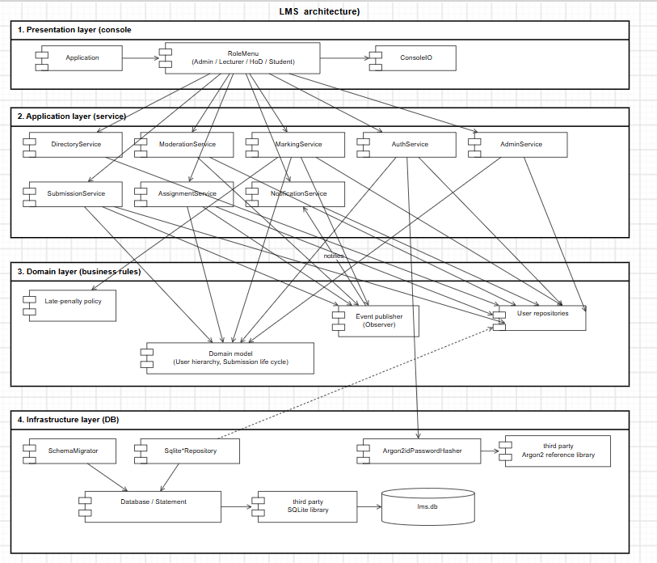
Layer | Folder / CMake target | Responsibility | Depend on
Presentation | app/ -> lms_ui, lms | Console menus per role, input validation and reprompting, formatting | Business-logic layer only
Application | lib/services, lib/domain, lib/policy, lib/events, lib/security -> lms_core | Use-case logic, access control, business rules, state machine, penalty strategy, notifications | Data-access interfaces
Domain access | lib/data -> lms_core | Repositories, SQL, transactions, migrations | SQLite
Storage | lms.db | Persistent data

Rules to be enforced in the code: the UI never includes a repository or SQL ,services receive repositories only through the Repositories bundle of interfaces and ITransactionRunner; only SqliteRepositories.cpp and Database.cpp contain SQL.

1.2 Design rationale
Why layered?
- The dominant quality attributes are integrity (moderation rules, audit), testability (penalty and deadline logic) and maintainability (a change request is expected). Layers put all rules in one place (lms core ) that is testable without a UI only console
- The data layer is replaceable. Moving from SQLite to a client/server database for multi-computer use would only require new repository implementations.
- The UI is replaceable which allows console or simple desktop GUI and a GUI could call the same services.
- It is simple enough for one developer and easy to explain at the viva.
Alternatives considered and rejected
Alternative | Why rejected
Model-View-Controller | MVC is designed for UIs with several views that update from a changing model (GUIs, web). A console UI shows one screen at a time and does not observe the model, so MVC's view/model synchronisation brings no benefit, and "controllers" would duplicate the use-case services. Separating presentation from logic, the part of MVC that matters here, is achieved by the layers.
Client-server (SQL server + thin clients) | It would allow several computers to work at once, but it breaks the IT officer's constraints: it needs a network (NFR-09) and server administration on old hardware. Deferred to a future release.
Single-module "big ball" (menus calling SQL directly) | Fastest to write, but rules would be scattered across menu code, untestable without typing into the console, and any later change request would touch many places.
Hexagonal (ports and adapters) | Very close to what was built (the repository interfaces are ports). Naming the whole system hexagonal would add ceremony (driving ports for a single console adapter) without benefit at this size.

Evidence from maintenance (CR1). Because the effective deadline is computed in exactly one method (AssignmentService::deadlineFor), the class-wide extension changed lateness, penalties, resubmission and reclassification everywhere without touching SubmissionService or MarkingService. Only 1 of 264 existing tests needed an update, and that was for an intentional display change.

1.3 Cross-cutting decisions
Decision | Choice | Reason
Time | int64 seconds since epoch (UTC) everywhere; local time only for display/input | Deadline comparison is exact integer arithmetic, with no time-zone or DST ambiguity (risk R5)
Clock | IClock injected (SystemClock in production, FixedClock in tests) | Deterministic tests of lateness boundaries
Errors | Exception hierarchy rooted at LmsError (ValidationError, AuthorizationError, BusinessRuleError, NotFoundError, DatabaseError, ...) | The UI catches LmsError in one place (Template Method RoleMenu::run) so no failure ends the session (NFR-08)
Transactions | ITransactionRunner using nested SQLite SAVEPOINTs | Mark + audit are atomic (NFR-07); services can nest safely
Password hashing | Argon2id via the PHC reference library | See section 5
Schema evolution | Numbered SQL migrations embedded at build time, PRAGMA user_version | One source of truth; CR1 (v1.1) added migration 002 without touching 001, and v1.0 databases upgrade in place

2. Detailed design - class diagrams
The design class diagram is shown as an overview plus three detailed views (a single diagram with every member is about 9 700 px wide and unreadable).
Overview (relationships)
Class diagram overview
View 1 - domain model, Factory and Strategy
Domain classes
View 2 - services and Observer
Service classes
View 3 - data access (Repository/DAO) and security
Data classes

2.1 Inheritance and polymorphism
User is abstract (pure virtual role(), roleTitle(), hasDepartmentScope(), permissions()). Administrator, Lecturer, HeadOfDepartment and Student are final subclasses. Role-specific behaviour is dispatched virtually:
- can(Permission) / require(Permission) use the subclass's permission set, which implements the access-control matrix (SRS 3.2).
- hasDepartmentScope(dept): Administrator -> true for all departments, HoD -> only their own, others -> false. ModerationService and the audit functions call this instead of testing the role.
- The UI picks the menu class through createMenuFor(user), and each menu class overrides title() and items().

2.2 Design patterns
Pattern | Where | Why it was chosen
Strategy | ILatePenaltyPolicy <- PercentPerDayPenaltyPolicy(10 %, 3 days), NoLatePenaltyPolicy; injected into MarkingService | The penalty rule was the most contested requirement (C2, C3) and the one most likely to change (a different rate, or waiving it for a course). With a strategy the rule can change without editing MarkingService, and it is unit-tested in isolation (IT_MRK.PenaltyStrategyIsInjectable swaps it).
Repository / DAO | IUserRepository, ISubmissionRepository, ... <- Sqlite*Repository | Isolates SQL (NFR-06 inspection is limited to one file), lets services be tested against an in-memory database, and makes a later move to a server database local to one layer.
Factory Method | UserFactory::create(UserRecord) | One place maps the stored role code to the concrete User subclass. AuthService returns unique_ptr<User> without knowing the subclasses; adding a role changes the factory only.
Observer | SubmissionEventPublisher / ISubmissionObserver <- NotificationService | Services announce life-cycle events (submitted, marked, released, extension) without depending on who reacts. Notifications were a Could requirement: removing or replacing them (e.g. SMS later) does not touch the services.
Template Method | RoleMenu::run() with abstract title() / items() | The session skeleton (greeting, notifications, menu loop, error handling) is written once, so every role gets identical robustness (NFR-08).
Composition root / Dependency Injection | LmsSystem | The only place that chooses concrete classes (SQLite, Argon2id, system clock, 10 % policy). Tests build the same graph with FixedClock, fast hash parameters or a different policy.

2.3 SOLID
Principle | How the design follows it | Example
Single responsibility | Each service owns one group of use cases; persistence, hashing, lateness and presentation are separate classes. | LatenessCalculator only counts days; PercentPerDayPenaltyPolicy only turns days into a deduction; MarkingService only orchestrates marking.
Open/closed | New behaviour is added by new classes, not by editing existing ones. | A new penalty rule is a new ILatePenaltyPolicy; a new notification channel is a new ISubmissionObserver; schema changes are new migration files.
Liskov substitution | Subclasses keep the base contracts: every User answers can() consistently, every policy returns a final mark within 0..raw. | UT_PEN.PolicyIsSubstitutableThroughInterface; UT_USR.PermissionMatrix tests all roles through User&.
Interface segregation | Seven small repository interfaces instead of one "Database" interface; IClock, IPasswordHasher, ITransactionRunner each have one or two methods. | AuthService depends only on IUserRepository, IPasswordHasher, IClock.
Dependency inversion | Services depend on abstractions that the data layer implements; concrete classes are chosen only in LmsSystem. | MarkingService(Repositories, ITransactionRunner&, const IClock&, ..., const ILatePenaltyPolicy&).

Known compromise: services receive the whole Repositories bundle (7 interfaces) even when they use 3 or 4 of them. This keeps constructors short. The cost is a slightly wider dependency than ISP would ideally allow; it is documented here as a deliberate trade-off.

3. Behavioural models

3.1 State machine - Submission life cycle
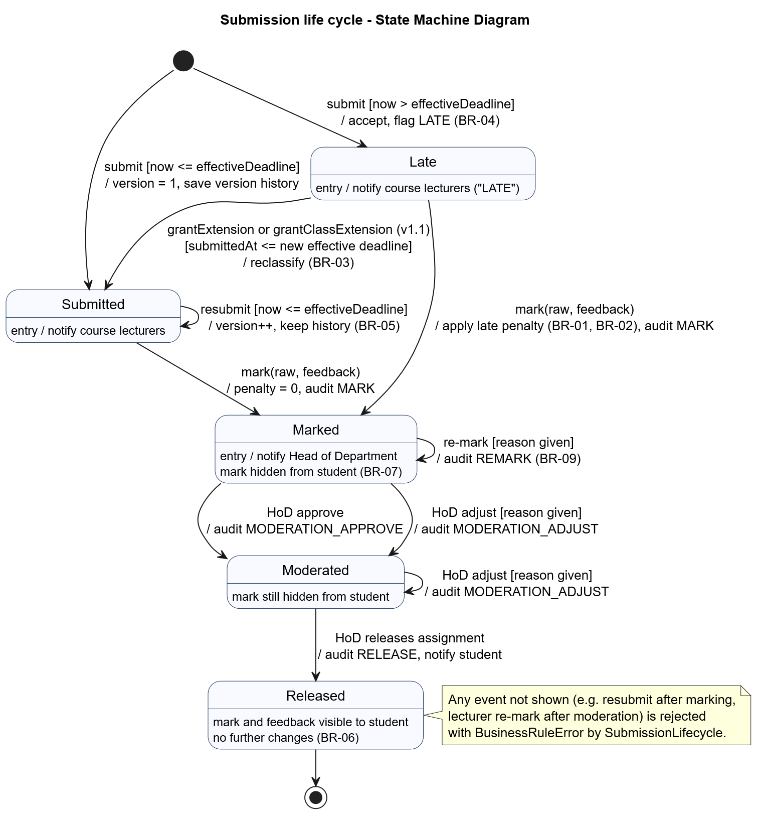
The table of legal transitions is implemented once in SubmissionLifecycle::canTransition and tested exhaustively (all 25 from/to pairs, UT_LIF.TransitionTable). Guards map to business rules: resubmission only while now <= effectiveDeadline (BR-05); re-mark and adjust only with a reason (BR-09); Released is final (BR-06).

3.2 Activity diagram - from submission to released mark
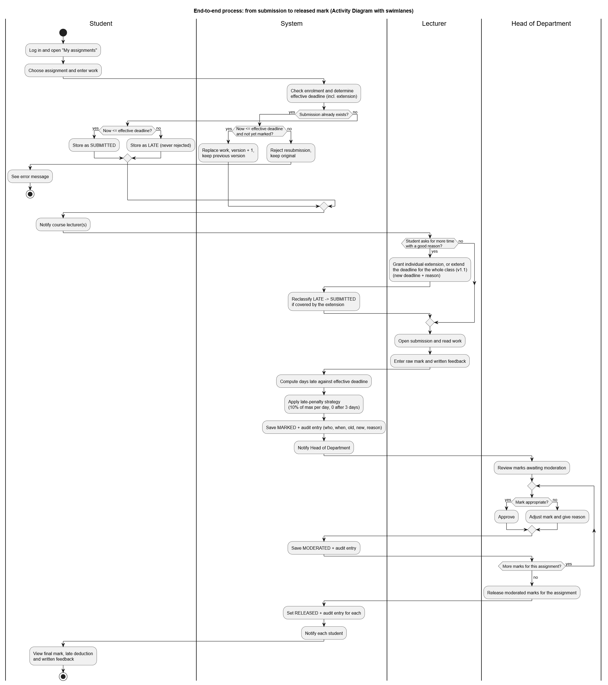
Swimlanes: Student, System, Lecturer, Head of Department. Decision points show the resubmission and late branches, the optional extension, and the moderation loop with approve/adjust.

3.3 Sequence diagram - UC-01 Submit assignment (incl. late and resubmission paths)
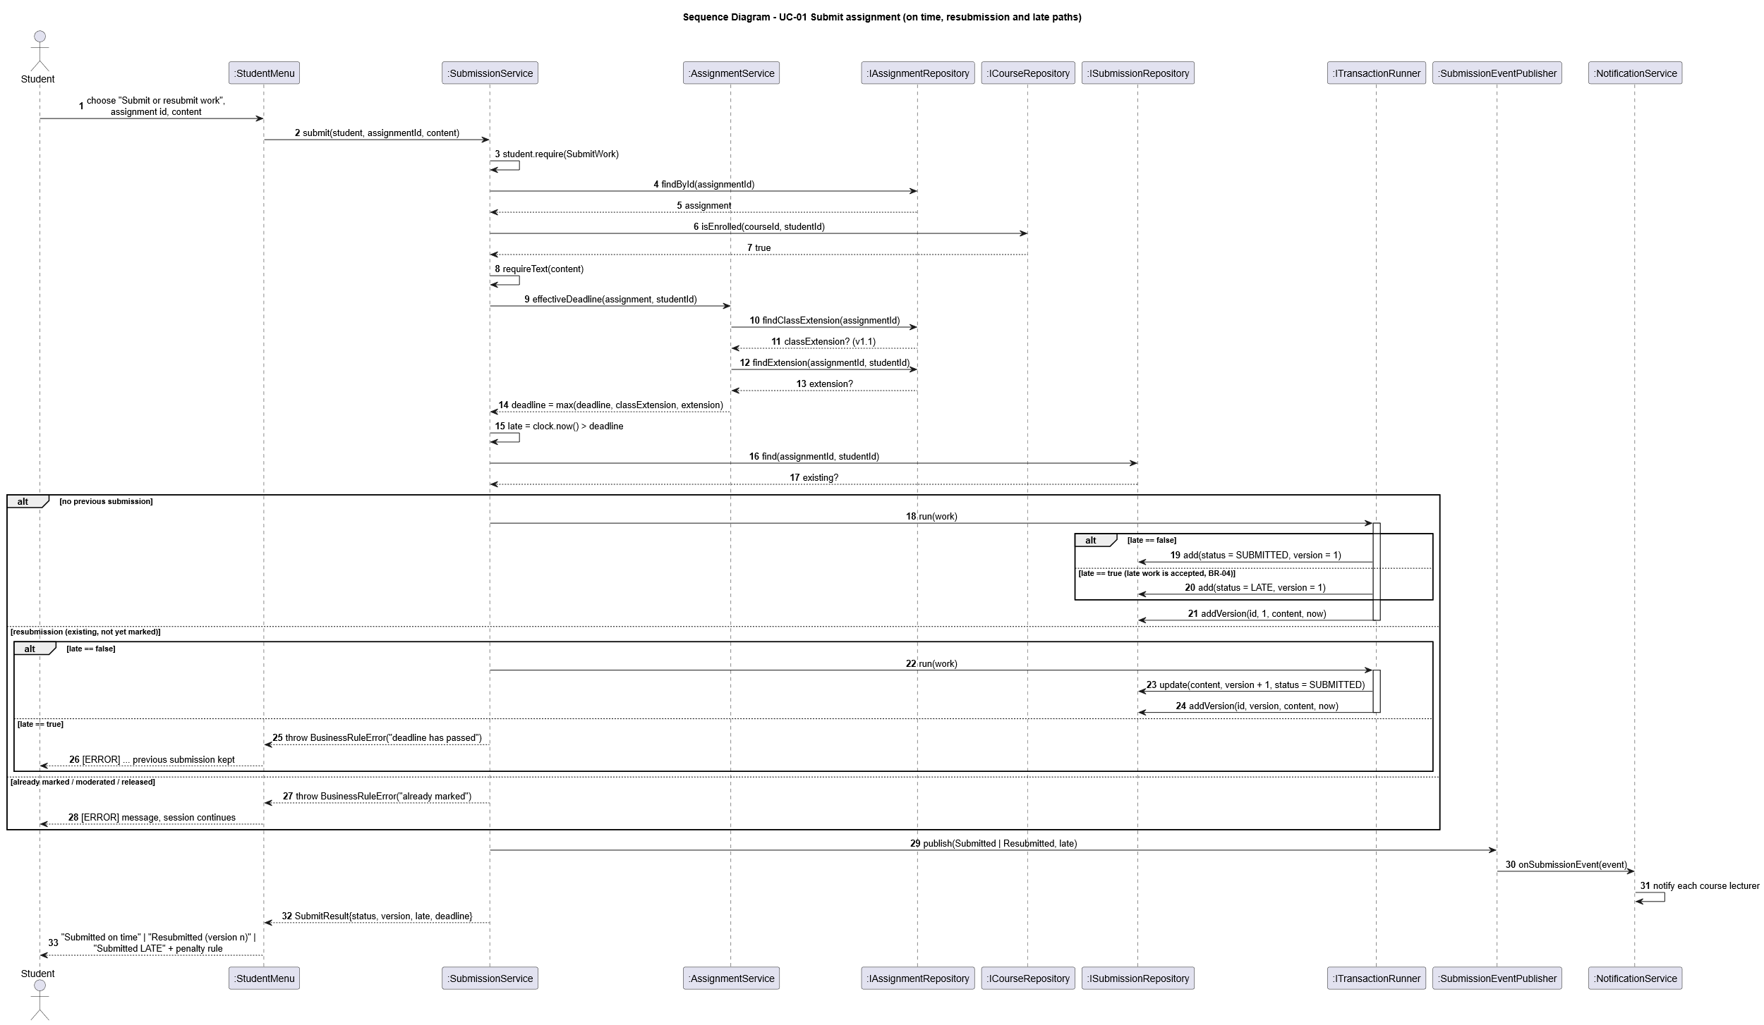

3.4 Sequence diagram - UC-03 Moderate and release marks
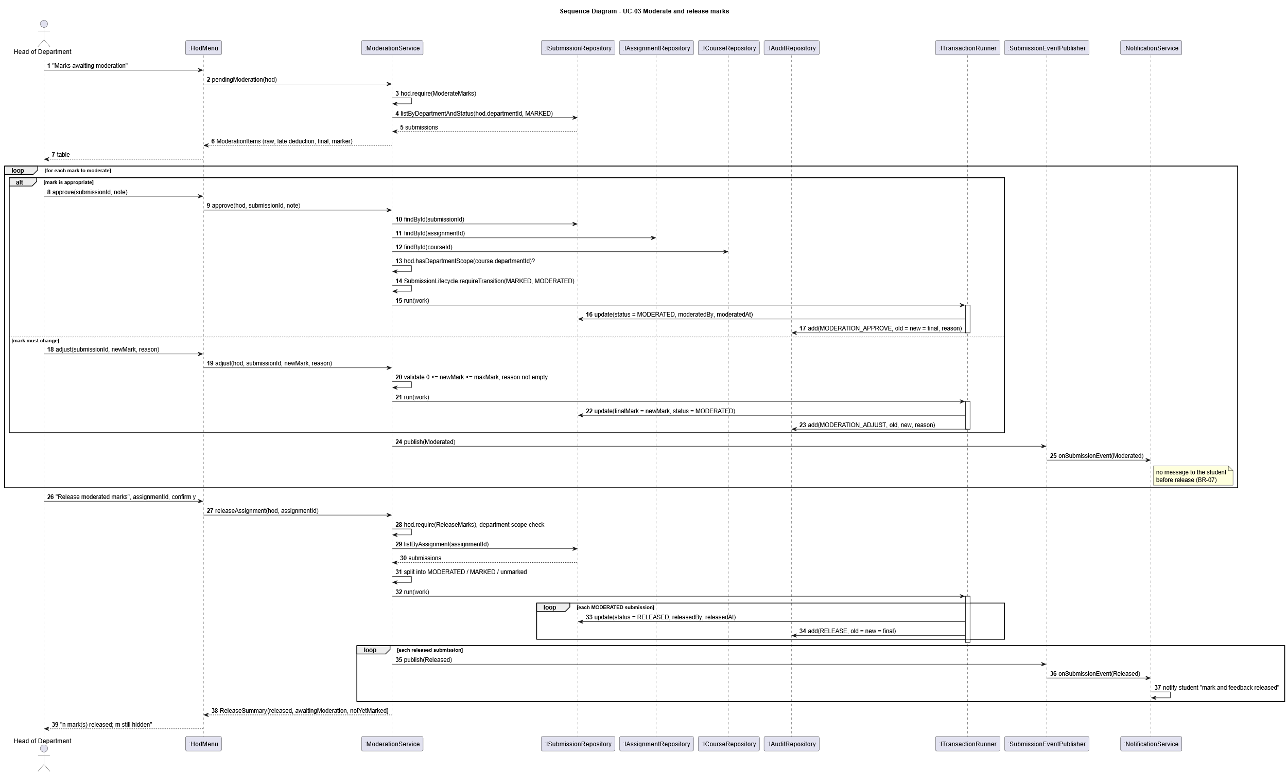

4. Database design

4.1 Entity-relationship diagram (3NF)
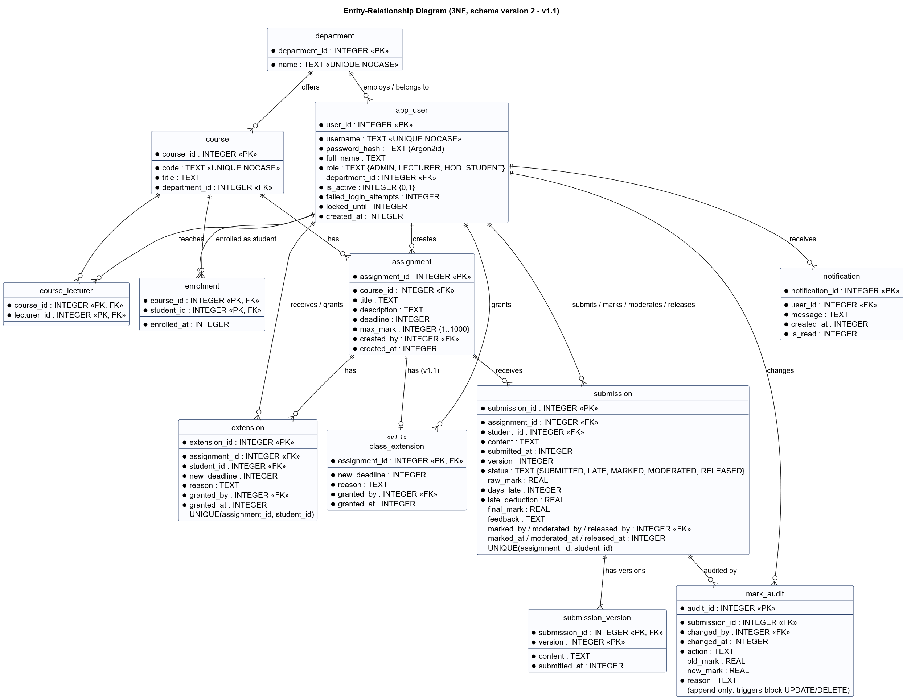
The authoritative SQL schema is sql/001_initial_schema.sql (v1.0) plus sql/002_class_extension.sql (v1.1, CR1). CMake embeds these files into the program (GeneratedMigrations.h), so the documentation, the tests and the executable cannot drift apart.

4.2 Normalisation
- 1NF: every column is atomic (no lists; lecturers of a course and enrolments are separate junction tables course_lecturer, enrolment; submission versions are rows in submission_version).
- 2NF: the tables with composite keys (course_lecturer, enrolment, submission_version) have no attributes that depend on part of the key (enrolled_at depends on the whole (course, student) pair).
- 3NF: no non-key attribute depends on another non-key attribute. The department of an assignment is reached via course and is not copied into assignment; the HoD of a department is derived from app_user(role='HOD', department_id) and is not stored in department, which would duplicate the fact and could contradict it. A partial unique index enforces one active HoD per department instead.
Checked candidate for a transitive dependency - submission.final_mark. At marking time final_mark = max(0, raw_mark - late_deduction), which looks derivable. It is stored anyway because (a) after moderation the HoD may set a different value, so it becomes an independent fact, and (b) an assessment record must not change silently if the penalty policy changes later: the stored days_late, late_deduction and final_mark are the recorded decision, and the audit log refers to them. Both reasons keep it within 3NF: final_mark is not functionally determined by other attributes once moderation exists.

4.3 Data dictionary
Table | Column | Type | Null | Constraint / meaning
department | department_id | INTEGER | N | PK
 | name | TEXT | N | UNIQUE (case-insensitive), 1-100 chars
app_user | user_id | INTEGER | N | PK
 | username | TEXT | N | UNIQUE NOCASE, 3-32 chars [A-Za-z0-9._-] (checked in service)
 | password_hash | TEXT | N | CHECK starts with $argon2id$ (encoded hash incl. parameters and salt)
 | full_name | TEXT | N | 1-100 chars
 | role | TEXT | N | CHECK in (ADMIN, LECTURER, HOD, STUDENT)
 | department_id | INTEGER | Y | FK department; CHECK required for HOD and LECTURER
 | is_active | INTEGER | N | 0/1; inactive users cannot log in
 | failed_login_attempts | INTEGER | N | >= 0; reset on success
 | locked_until | INTEGER | N | epoch seconds; 0 = not locked
 | created_at | INTEGER | N | epoch seconds
course | course_id | INTEGER | N | PK
 | code | TEXT | N | UNIQUE NOCASE, 1-20 chars
 | title | TEXT | N | 1-100 chars
 | department_id | INTEGER | N | FK department (RESTRICT)
course_lecturer | course_id, lecturer_id | INTEGER | N | composite PK; FKs; service ensures same department (BR-11)
enrolment | course_id, student_id | INTEGER | N | composite PK; FKs
 | enrolled_at | INTEGER | N | epoch seconds
assignment | assignment_id | INTEGER | N | PK
 | course_id | INTEGER | N | FK course
 | title | TEXT | N | 1-200 chars
 | description | TEXT | N | default ''
 | deadline | INTEGER | N | epoch seconds; in the future at creation (service)
 | max_mark | INTEGER | N | CHECK 1..1000
 | created_by, created_at | INTEGER | N | FK app_user; epoch
extension | extension_id | INTEGER | N | PK
 | assignment_id, student_id | INTEGER | N | FKs; UNIQUE pair (one extension per student per assignment)
 | new_deadline | INTEGER | N | > assignment.deadline (service)
 | reason | TEXT | N | non-empty (BR-09)
 | granted_by, granted_at | INTEGER | N | FK app_user; epoch
submission | submission_id | INTEGER | N | PK
 | assignment_id, student_id | INTEGER | N | FKs; UNIQUE pair (current submission)
 | content | TEXT | N | current version's work
 | submitted_at | INTEGER | N | time of current version
 | version | INTEGER | N | >= 1
 | status | TEXT | N | CHECK in (SUBMITTED, LATE, MARKED, MODERATED, RELEASED)
 | raw_mark | REAL | Y | >= 0; required once MARKED (table CHECK)
 | days_late | INTEGER | N | >= 0, computed at marking
 | late_deduction | REAL | N | >= 0
 | final_mark | REAL | Y | >= 0; required once MARKED
 | feedback | TEXT | Y | mandatory at marking (service, BR-10)
 | marked_by/at, moderated_by/at, released_by/at | INTEGER | Y | FK app_user / epoch
submission_version | submission_id, version | INTEGER | N | composite PK; FK CASCADE
 | content, submitted_at | TEXT, INTEGER | N | history of every (re)submission
mark_audit | audit_id | INTEGER | N | PK
 | submission_id, changed_by | INTEGER | N | FKs
 | changed_at | INTEGER | N | epoch
 | action | TEXT | N | CHECK in (MARK, REMARK, MODERATION_APPROVE, MODERATION_ADJUST, RELEASE)
 | old_mark, new_mark | REAL | Y | final mark before / after
 | reason | TEXT | N | non-empty; triggers forbid UPDATE and DELETE
notification | notification_id | INTEGER | N | PK
 | user_id | INTEGER | N | FK CASCADE
 | message, created_at, is_read | TEXT, INTEGER, INTEGER | N
class_extension (v1.1) | assignment_id | INTEGER | N | PK and FK assignment (at most one class extension per assignment)
 | new_deadline | INTEGER | N | > assignment.deadline (service)
 | reason | TEXT | N | non-empty
 | granted_by, granted_at | INTEGER | N | FK app_user; epoch

Indexes: ix_enrolment_student, ix_assignment_course, ix_submission_student, ix_submission_status, ix_mark_audit_submission, ix_notification_user, ix_course_department, ix_course_lecturer_lecturer, ix_app_user_role. These support the queries the NFR-01..03 measurements depend on.

4.4 Mapping classes to tables
Class (C++) | Table(s) | Differences and justification
User hierarchy (4 subclasses) + UserRecord | app_user | Single-table inheritance. The subclasses add behaviour, not data, so one table with a role discriminator avoids four identical tables and joins at login. UserRecord is the persistence DTO; password_hash, failed_login_attempts and locked_until live only there, so they never reach the UI (UserSummary).
Department, Course, Assignment | department, course, assignment | 1:1
(no class) | course_lecturer, enrolment | Many-to-many associations Course -- Lecturer/Student become junction tables; exposed as repository methods (assignLecturer, enrol, isEnrolled) rather than classes because they carry no behaviour.
Extension | extension | 1:1
Submission | submission + submission_version | The class holds the current version; history is a separate table (1NF) used for disputes and exposed through ISubmissionRepository::addVersion/countVersions.
SubmissionStatus (enum) | submission.status TEXT + CHECK | Stored as readable codes rather than integers so the database remains understandable to an auditor.
MarkAuditEntry, AuditAction | mark_audit | 1:1; append-only is enforced in the database, not only in code.
Notification | notification | 1:1
ClassExtension (v1.1) | class_extension | 1:1; assignment_id is the key because there is at most one per assignment
ExtensionKind, DeadlineInfo (v1.1) | - | Computed by AssignmentService::deadlineFor (latest of original, class, individual); not stored, to avoid a derived column
Services, policies, publisher | - | Behaviour only; no persistence.

5. Security design
Threat | Control | Where
Stolen database reveals passwords | Argon2id (winner of the Password Hashing Competition, RFC 9106), m = 19 MiB, t = 2, p = 1, 16-byte salt from the OS CSPRNG (BCryptGenRandom / /dev/urandom); encoded string stores parameters, so they can be raised later | Argon2idPasswordHasher
Brute force at the console | 5-failure lockout for 15 min; generic message; admin reset | AuthService
Username enumeration by timing | Unknown user still performs one hash verification (review finding R1) | AuthService
SQL injection | Only prepared statements with bound parameters; no SQL in UI/services | Statement::bind, repositories
Tampering with marks | Role/department checks in every service call; state machine; append-only audit table with triggers | services, schema
Shoulder surfing | Password input without echo | ConsoleIO::readPassword
Exfiltration through file submission | @file refuses the database file and files > 100 KB | StudentMenu

Why Argon2id and the PHC reference library. Bcrypt truncates passwords at 72 bytes and is not memory-hard. PBKDF2 (e.g. via OpenSSL) is not memory-hard, so GPU attacks are cheap, and pulling in OpenSSL for one function is heavy to build offline on Windows. scrypt is memory-hard but has no standardised encoded format in common C libraries. Argon2id is the OWASP-recommended first choice, and the PHC reference implementation is small, portable C (6 files, CC0/Apache-2.0) built from a pinned, hash-verified source. libsodium's crypto_pwhash would be equally acceptable; it was not chosen because its CMake/Windows build is heavier than needed.

